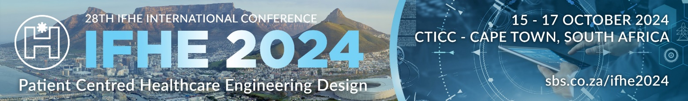

 | 2024 INTERNATIONAL IFHE BUILDING AWARD CONTEST SUBMISSION FORM

SUBMISSION REFERENCE NUMBER | For office use only

Please ensure that you read and understand the information here:
https://sbs.co.za/ifhe2024-awards/#IFHEBuildingAwards

You must complete all sections of the application form. If any sections are not relevant for the project, please indicate by entering N/A as a response.

SECTION 1: PROJECT INFORMATION
Submission Date (dd/mmy/yyyy)
Project Name
Project Type / Building Technology
Project Location (City / Country)
Project Team
Project Completion Date (Month / Year)*
Project Value in US Dollars
Project Size (m²)
Building Size (m²) – if renovation or alteration project
Primary Applicant’s Contact Name
Primary Applicant’s Organisation Name
Primary Applicant’s Email Address
Pease confirm that there will be at least one representative registered for the IFHE 2024 Conference?

*In all cases, the projects considered for the award will be the ones realized and completed in or after 2019 and the buildings must be in operation when they are proposed for the contest.

SECTION 2: PROJECT TEXT SUBMISSION

Tell us about your project in no more than 300 words and ensure that you cover the following criteria:

- Design for physical health & wellbeing. This could include elements such as the provision of natural and artificial lighting, air quality, acoustics, hygiene and occupant comfort.
- Design for mental health & wellbeing. This focuses on how the building supports the mental health and wellbeing of its occupants.
- Design for accessibility. Encouraging participation of a range of occupant types including those with psychological needs as well as those with physical needs.
- Encouragement of independence. Giving patients or residents the ability to make choices, particularly relating to balancing social interaction and privacy.
- Design for functionality for everyday activities. Focusing on the experience of staff and visitors as well as patients or residents.
- Contribution to urban context. The interaction with and contribution to the community surrounding the facility.
- Environmental sustainability. Addressing the impact of the construction as well as the operation of the building.
- Design innovation and contribution to best practice. Highlighting how the building has contributed to new knowledge about the design, construction or operation of healthcare facilities.
- Sustainability characteristics. The project must propose innovative solutions with regard to sustainability of the building, especially measures for energy saving and eventual use of renewable energy sources, water saving methods, intelligent waste disposal or re-use procedures.

SECTION 2 TEXT SUBMISSION
(add text – no more than 300 words – to the row below)
Please specify the number of words used in your text submission above

SECTION 3: PROJECT PHOTOGRAPHS

A minimum of 8 and maximum of 20 photographs must be added here – one photograph per row – as 300 dpi JPEG or PNG files with a minimum ratio of 1180px or 10cm on the shortest side.

Please add a short description to the right of the picture number in each applicable row below.

Picture 1 (required): Add photo description over this text
Add photo here and delete text

Picture 2 (required): Add photo description over this text
Add photo here and delete text

Picture 3 (required): Add photo description over this text
Add photo here and delete text

Picture 4 (required): Add photo description over this text
Add photo here and delete text

Picture 5 (required): Add photo description over this text
Add photo here and delete text

Picture 6 (required): Add photo description over this text
Add photo here and delete text

Picture 7 (required): Add photo description over this text
Add photo here and delete text

Picture 8 (required): Add photo description over this text
Add photo here and delete text

Picture 9:
Picture 10:
Picture 11:
Picture 12:
Picture 13:
Picture 14:
Picture 15:
Picture 16:
Picture 17:
Picture 18:
Picture 19:
Picture 20:

Completed application forms must be submitted as an MS Word document via email or WeTransfer to cgodfrey@kit-group.org by no later than 20 September 2024.

Should you have any questions, please email cgodfrey@kit-group.org.

